For Loop in C
Platform: HackerRank
Language: C
Module 3, Question 1

Problem Link
https://www.hackerrank.com/challenges/for-loop-in-c/problem

Problem Statement
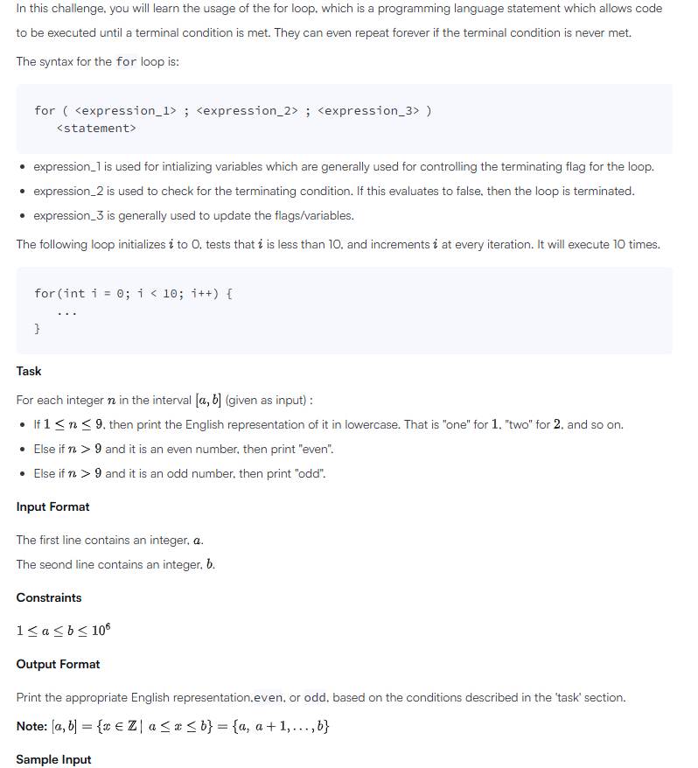

C Code
#include <stdio.h>

int main() {
int a, b;
scanf("%d", &a);
scanf("%d", &b);

char *words[] = {"zero", "one", "two", "three", "four",
"five", "six", "seven", "eight", "nine"};

for (int n = a; n <= b; n++) {
if (n <= 9)
printf("%s\n", words[n]); // 1 to 9 are printed as words
else if (n % 2 == 0)
printf("even\n");
else
printf("odd\n");
}
return 0;
}

Screenshot of Successful Submission



